The following document summarizes changes to the “Somnormal” app that will serve as a starting point for the “Cervella” app.

以下文档总结了“Somnormal”应用程序的变化，该程序将作为“Cervella”应用程序的起点。

Once the following changes are completed, we can have a basic functional Cervella app that can be tested and submitted to the FDA.

一旦完成以下更改，我们就可以拥有一个可以测试并提交给FDA的基本功能Cervella应用程序。

Overall changes:

1. Change clock format from 24h to 12h (AM/PM) which is the norm in USA.

将时钟格式从24小时改为12小时（AM / PM），这在美国是常态.

1. If able, change all font to “Neometric” (font file provided) / 如果能够，将所有字体更改为“Neometric”（根据Bart提供的字体文件）
2. Patient data MUST be stored anonymously on the server OR only stored on smart device only. We cannot have any Personable Identifiable Information (not even e-mail) stored on the server.

患者数据必须匿名存储在服务器上或仅存储在智能设备上。我们不能在服务器上存储任何可识别个人信息（甚至不是电子邮件）

START-UP

1. Replace the title screen with the title screen that shows the “Cervella” logo on white background. / 将标题屏幕替换为在白色背景上显示“Cervella”标志的标题屏幕。
   1. If able, show app version on the start-up screen (e.g. Version 1.0) 如果可以，在启动屏幕上显示应用程序版本（例如版本1.0）

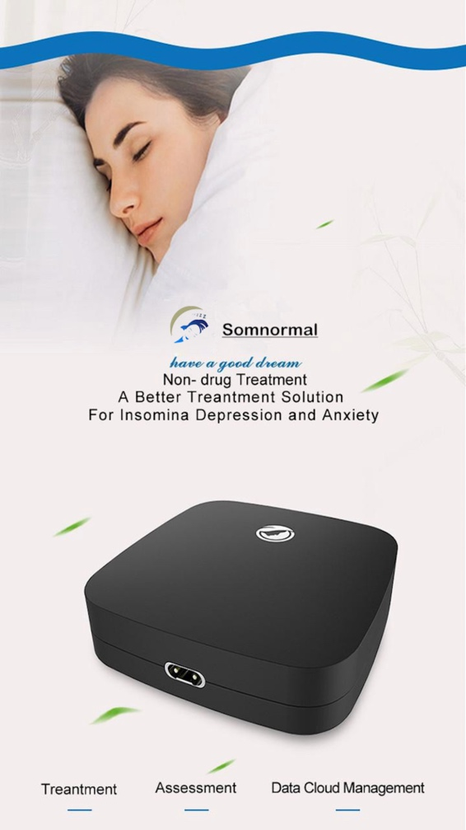

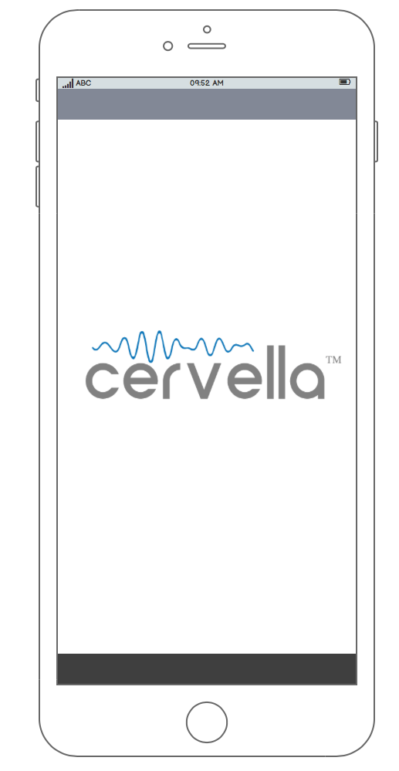

Version 1.0

ACCOUNT LOGIN AND REGISTRATION

1. Replace the word “Somnormal” with “Cervella” logo if able or, if not able, just word “Cervella”

如果可以的话使用“Cervella”标志替换“Somnormal”一词，或者如果不能使用“Cervella”文字。

1. Replace word “Account” with “Username” / 用“Username”替换“Account”

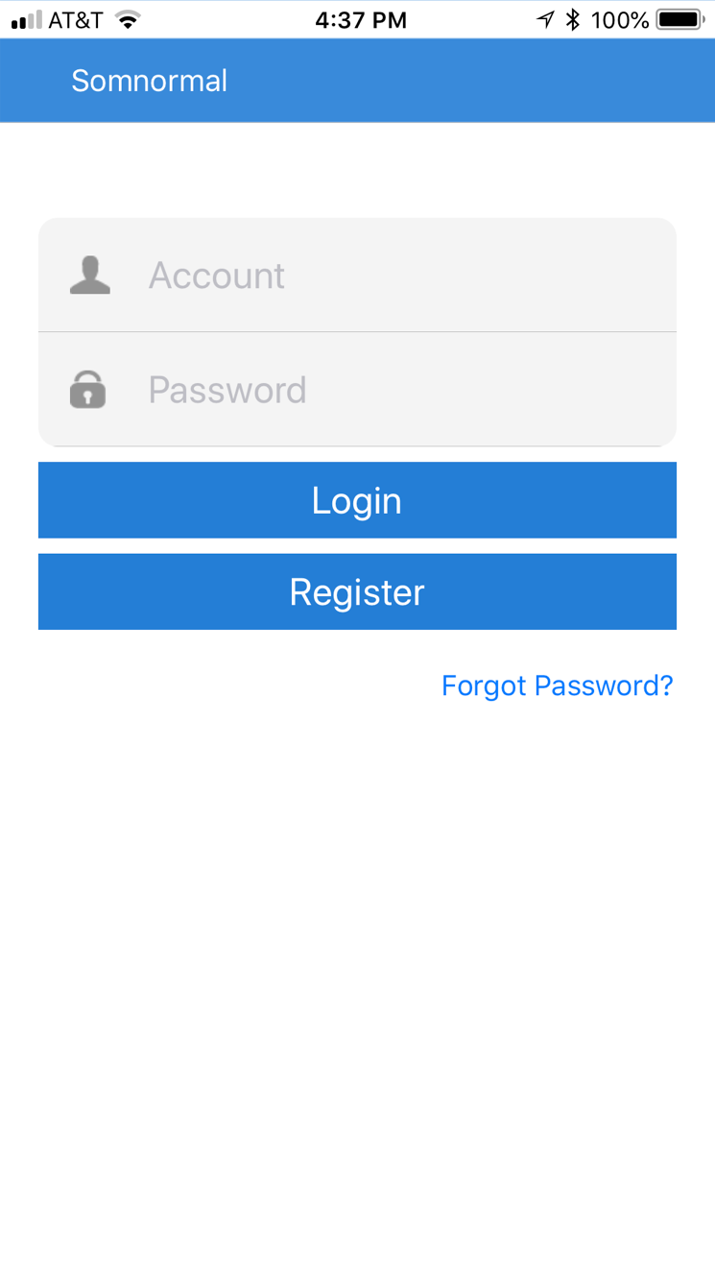

Note: If user just clicks on “Forgot Password” without typing user name, message “Account number must be entered. Please check and re-enter” appears. Rename this text to “Please enter Username first”.

注意：如果用户只需点击“忘记密码”而不输入用户名，则必须输入“必须输入帐号”。请检查并重新输入“出现。将此文字重命名为“请先输入用户名”。

Also, if user provided e-mail at log-in but user e-mail is blank under “My Information”, a message appears, “Your email is empty.” This is a bug in the software I think since the user did provide an e-mail at registration. So, this begs the question, what is the e-mail at registration used for.

此外，如果用户在登录时提供了电子邮件，但在“我的信息”下用户电子邮件为空白，则会显示一条消息“您的电子邮件为空”。这是我认为用户提供的软件中的一个错误在注册时发送电子邮件。所以，这引出了一个问题，那就是用于注册的电子邮件是什么。

1. Replace word “Account” with “Username” / 用“Username”替换“Account”
2. Remove “Birthday” and gender “M” and “F” / 删除“生日”和性别“M”和“F”
3. Add the Terms of Use and the “I AGREE” checkbox as shown below. 添加使用条款和“I AGREE”复选框，如下所示。
4. If user does not enter e-mail address, message appears: “Mailbox address entered incorrectly. Please check and re-enter.” Change to: “Please provide a valid e-mail address.” / 如果用户没有输入电子邮件地址，则会显示以下消息：“邮箱地址输入不正确。请检查并重新输入。“更改为：”请提供有效的电子邮件地址。“

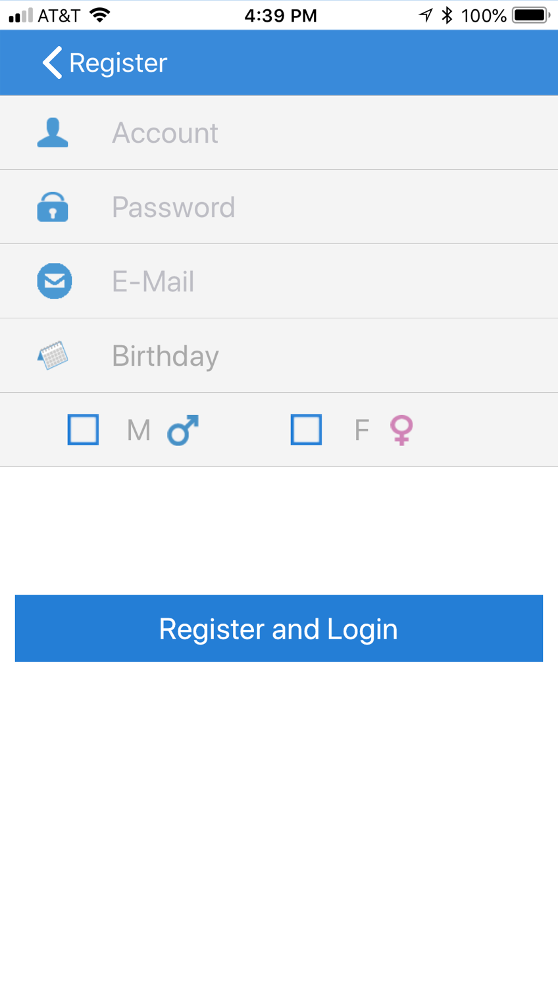

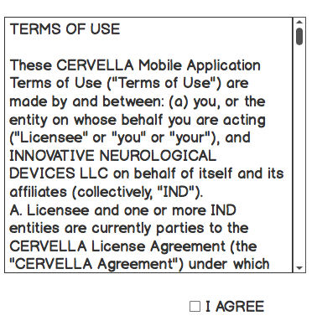

HOME SCREEN

1. Change word “Somnormal” to “Cervella” /将“Somnormal”更改为“Cervella”
2. Change word “Start” to “Home” (Make it a HOME symbol if able). The symbol is gray or blue depending whether the user is on the screen selected by the symbol or not.

将单词“Start”更改为“Home”（如果可以，请将Home设为首页符号）。符号是灰色还是蓝色，取决于用户是否在符号选择的屏幕上。

1. Change word “Assess” to “Treatment Data” (Make it a Treatment Data symbol if able). Link this to the Treatment Data. The symbol is gray or blue depending whether the user is on the screen selected by the symbol or not.

将“Assess”一词改为“Treatment Data”（如果可以，将其作为治疗数据符号）。将其链接到治疗数据。符号是灰色还是蓝色，取决于用户是否在符号选择的屏幕上。

1. Change word “Me” to “User Data” (Make it a symbol for USER if able) and link it to My Information. The symbol is gray or blue depending whether the user is on the screen selected by the symbol or not. 

将单词“Me”更改为“User Data”（如果可以，请将它作为用户的符号）并将其链接到My Information。符号是灰色还是蓝色，取决于用户是否在符号选择的屏幕上。

1. Change words “Intensity Control” to “Intensity Level” /将“Intensity Control”更改为“Intensity Level”
2. Make the default Intensity Level “1”. This should always be “1” when app starts. /设置默认强度等级“1”。当应用程序启动时，这应始终为“1”。
3. The number of intensity levels is 10 from 50uA to 500uA with a 50uA step. /强度级别的数量从50uA到500uA为10，步长为50uA。
4. Change word “Mode” to “Frequency” /将单词“Mode”更改为“Frequency”
5. Change words “Mode 1” to “0.5Hz”, “Mode 2” to “1.5Hz”, and “Mode 3” to “100Hz” / 将“模式1”改为“0.5Hz”，“模式2”改为“1.5Hz”，将“模式3”改为“100Hz”
6. Make the default mode 100Hz. / 使默认模式为100Hz
7. Change the word “Unbound” to “Unpaired” /将“Unbound”改为“Unpaired”

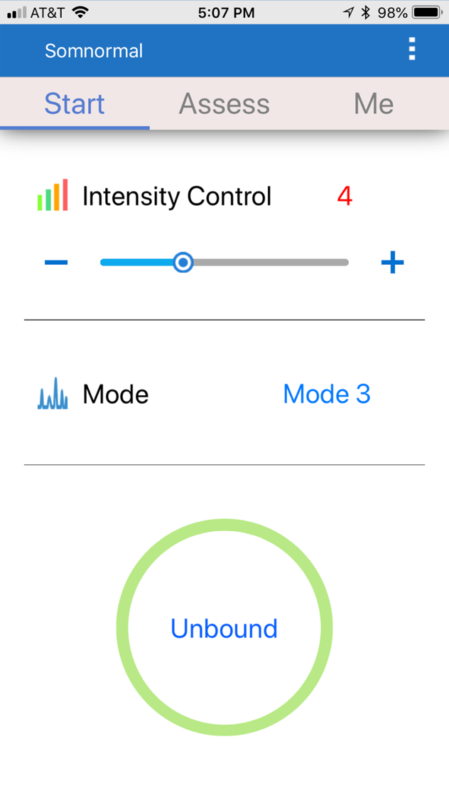

1. If able, add DURATION control selectable by user from 10 min to 60 min. 30 min default as shown in the example below: / 如果可以，请将用户可选的DURATION控制从10分钟增加到60分钟。默认30分钟，如下例所示：

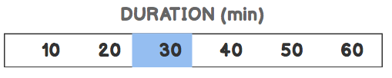

HOME SCREEN

PAIRING

1. Change word “Binding” to “Pairing”

将单词“Binding”更改为“Pairing”

1. Change word “Unconnected” to “Not Connected”

将“Unconnected”改为“Not Connected”

1. Change word “Search Somnormal” to “Search for Cervella”

将单词“Search Somnormal”更改为“Search for Cervella”

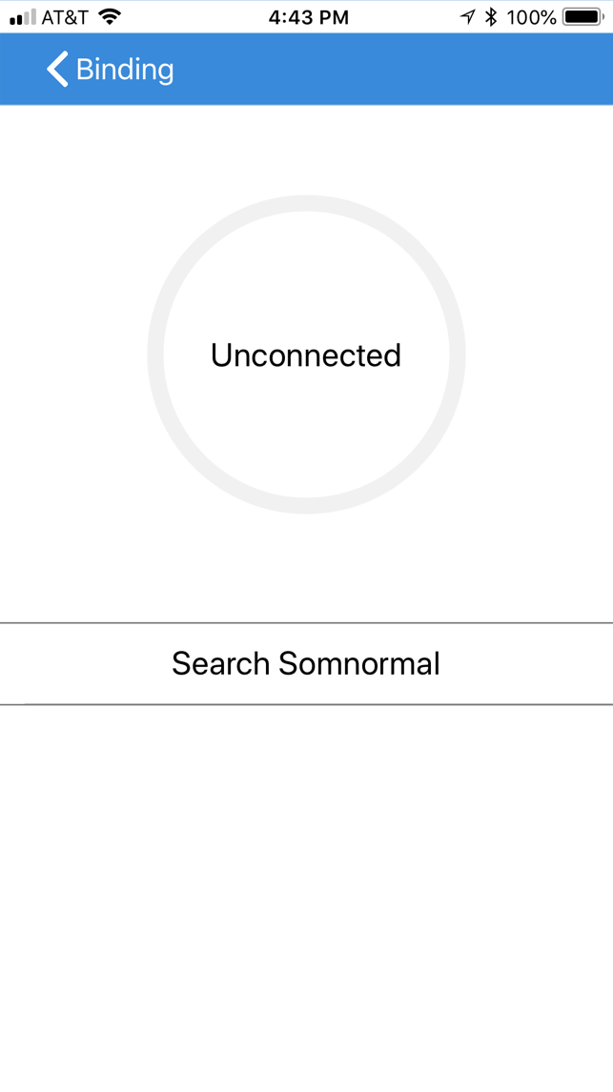

1. Change the text “Please ensure….” to “Ensure that your Cervella device is charged and placed nearby and verify that the Bluetooth function is enabled on your smart device. To pair, simply select your Cervella device from the list below.”

将“Please ensure….”改为：“Ensure that your Cervella device is charged and placed nearby and verify that the Bluetooth function is enabled on your smart device. To pair, simply select your Cervella device from the list below.”

1. Change “Sleep4U-XXXXX” to “Cervella-XXXXXXX”

将 “Sleep4U-XXXXX” 改为 “Cervella-XXXXXXX”

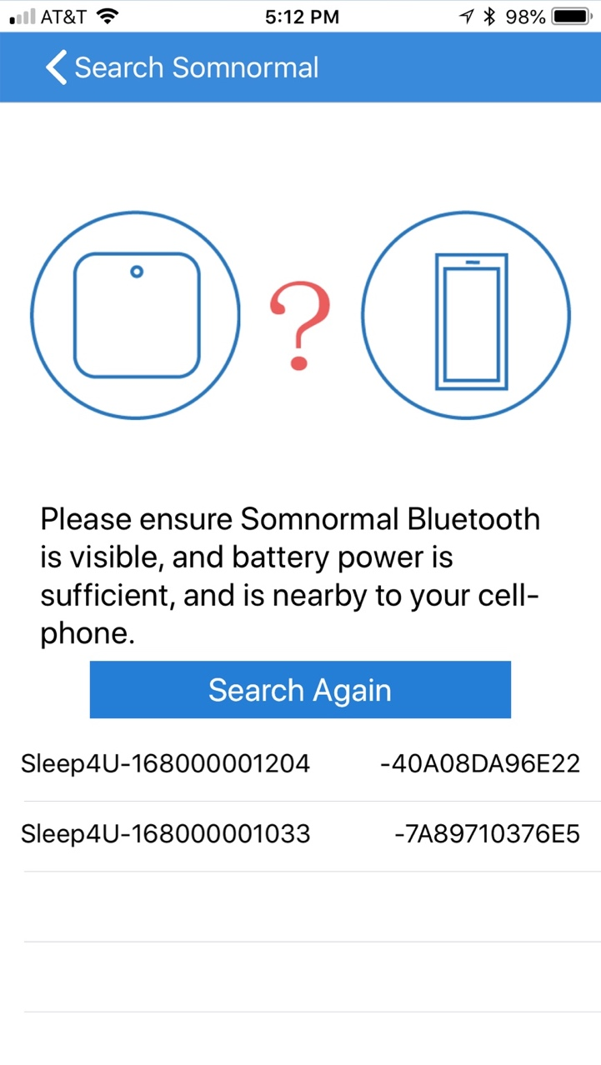

1. Change word “Binding” to “Pairing”

将单词“Binding”更改为“Pairing”

1. Label the circle below with “Cervella’s Battery Level”. Label under circle.

用“Cervella's Battery Level”标出下面的圆圈。在圈子下标签。

1. Change words “Unbind Somonormal” to “Unpair Cervella”

将单词“Unbind Somonormal” 更改为“Unpair Cervella”

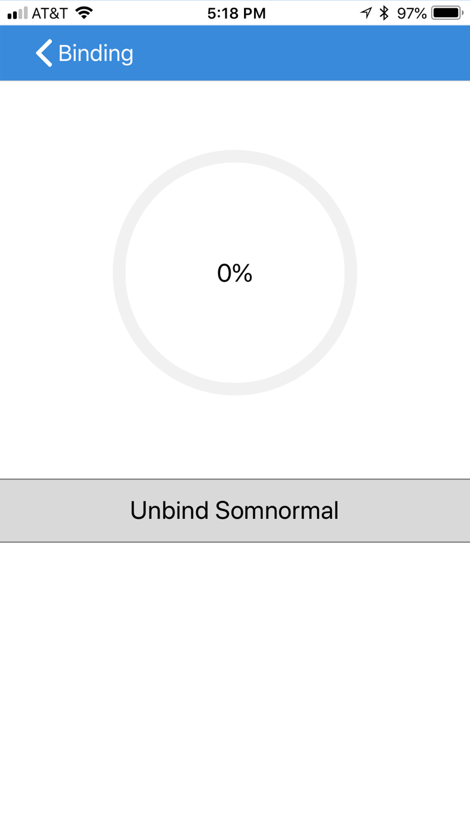

1. Change words “Unbind Somnormal” to “Unpair Cervella”

将单词“Unbind Somnormal”改为“Unpair Cervella”

1. Change the “Unbind after, …” to “Unpairing will cause Cervella to stop working with your smart device. Use this feature if you would like to pair your Cervella with another smart device.”

将 “Unbind after，...”更改为“Unpairing will cause Cervella to stop working with your smart device. Use this feature if you would like to pair your Cervella with another smart device.”

1. Change “Unbind Somnormal” to “Unpair Cervella”

将“Unbind Somnormal”更改为“Unpair Cervella”

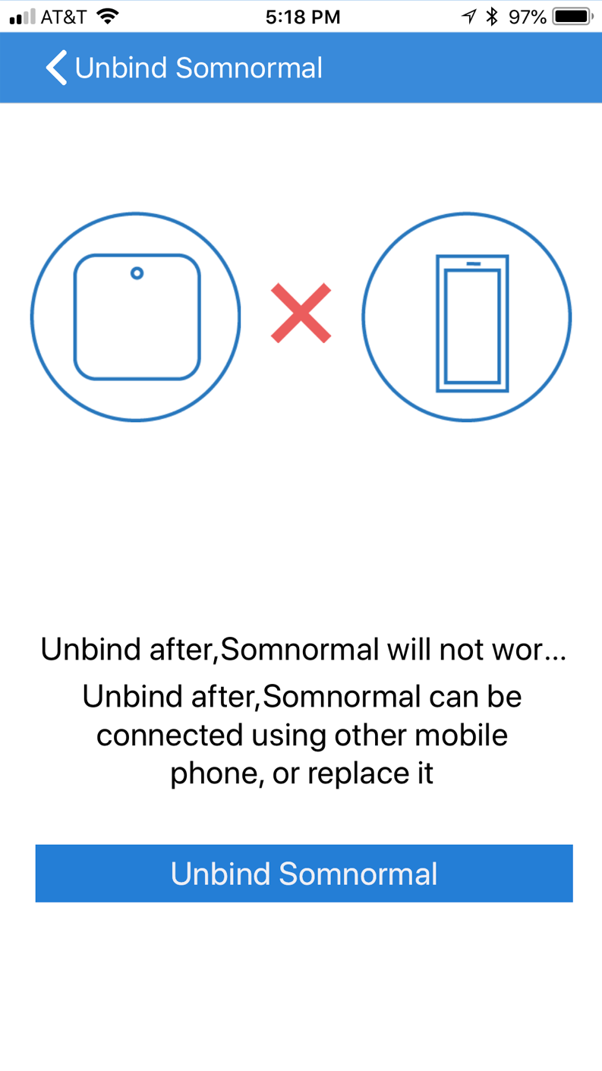

TREATMENT DATA

1. When the user clicks on “Assess” (now called “Treatment Data”), Treatment Data screen shows as shown below.

当用户点击“Assess”（现称为“Treatment Data”）时，治疗数据屏幕显示如下。

1. Rename “Level” with Intensity, “Mode” with “Freq.” and “Period” with “Duration”.

将Intensity重命名为“Level”，将 “Mode”重命名为“Freq.”，将 “Period”重命名为“Duration”。

1. Change the clock from 24h clock to US clock (AM/PM).

时钟从24小时更改为美国时钟（AM / PM）

1. Use Blue/White color scheme for the rows as shown on the screen on the right vs. Blue/Orange.

对蓝色/白色配色使用蓝色/白色配色，如右侧蓝色/橙色屏幕所示。

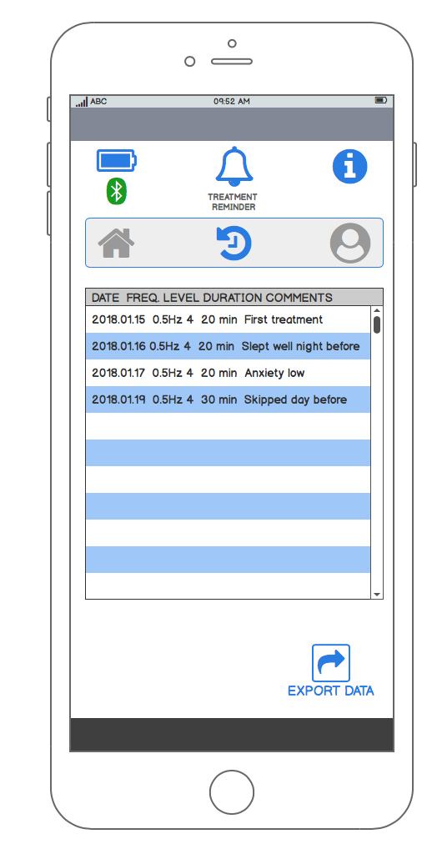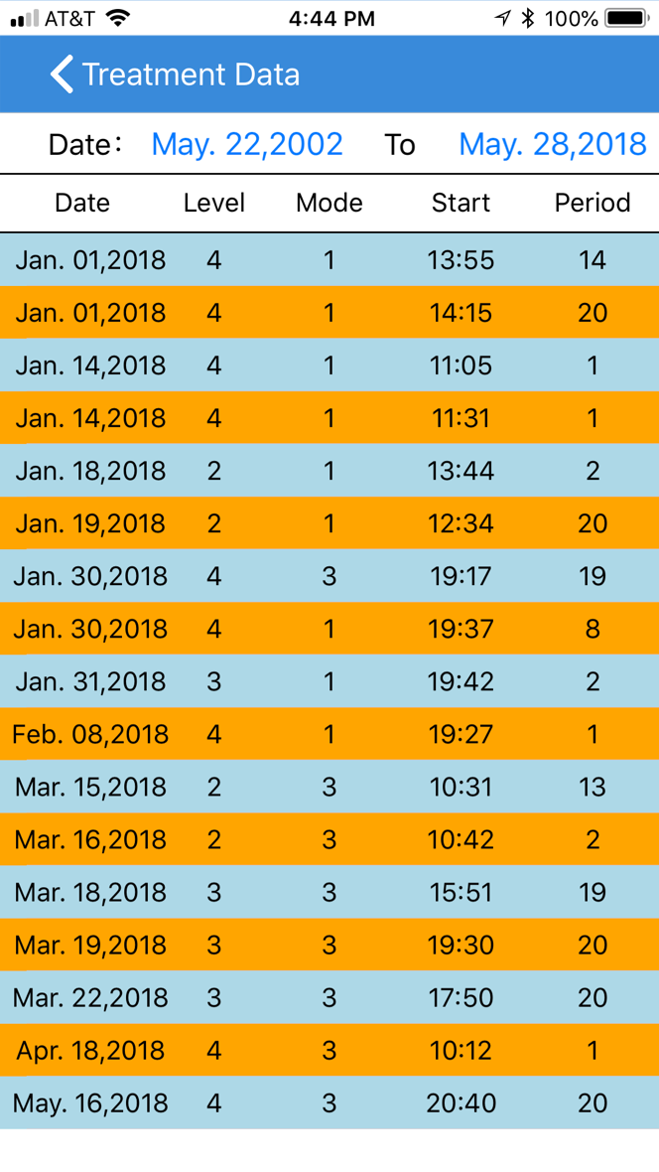

DROP-DOWN MENU

1. Rename word “Binding” to “Pairing”. Change the icon to the Bluetooth logo if able as shown below. (Symbol should be on blue background)

将单词“Binding”重命名为“Pairing”。如果能够将图标更改为蓝牙标志，如下所示。 （符号应该在蓝色背景上）

1. Remove the “About” menu.

删除“关于”菜单

1. Change the symbol “?” for Help to show the “i” as on shown below. (Symbol should be on blue background).

更改Help的符号从“？”为“i”，如下所示：

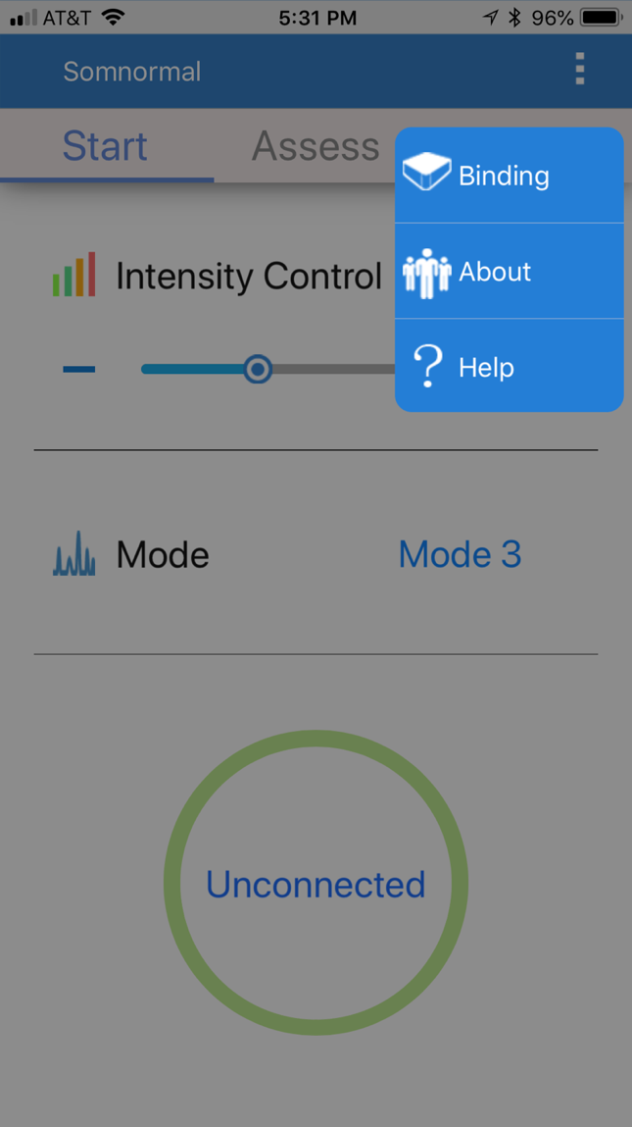

USER DATA SCREEN

1. When the user clicks on “Me” (now renamed “User Data”), the contents of the screen “My Information” is shown.

当用户点击“Me”（现在更名为“User Data”）时，会显示“My Information”屏幕的内容。

1. Remove Sex

删除“性别”

1. Remove Birthday

删除“生日”

1. Remove “Contact” field.

删除“联系电话”

1. Remove “Address” field.

删除“地址”

NOTE: the e-mail should be auto-populated from the e-mail the user used at registration.

电子邮件应该从用户在注册时使用的电子邮件自动填充。

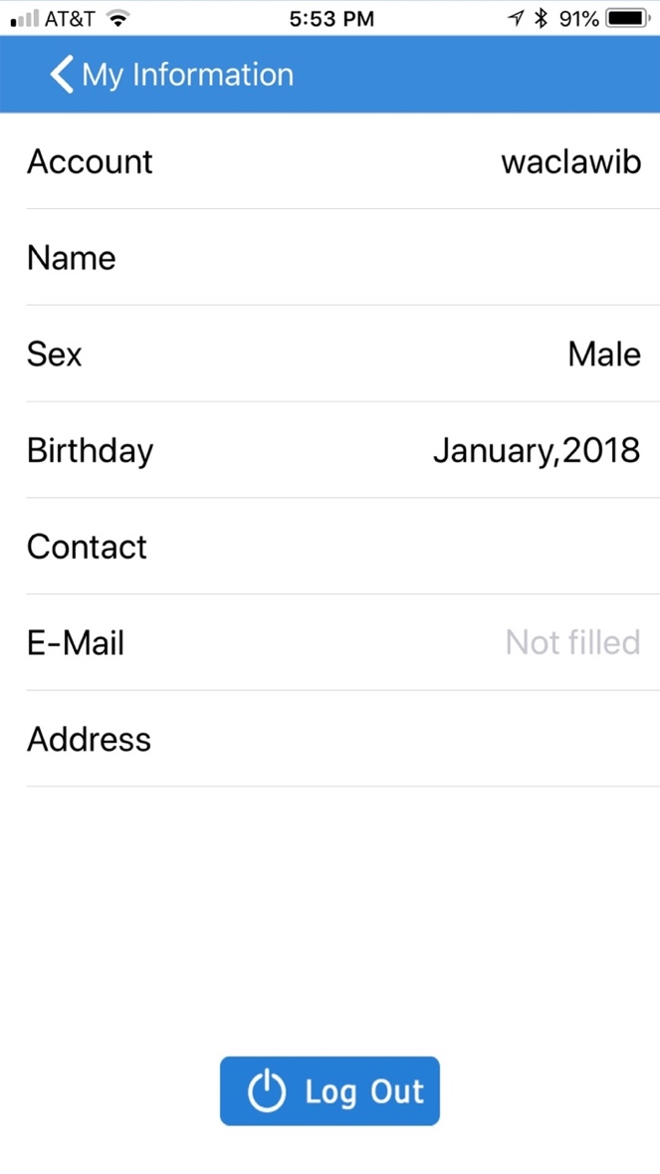

1. When the user clicks on “Help”, the following screen is shown that combines contents of About and Help onto one screen.

当用户点击“Help”时，显示下面的屏幕，其将Somnormal 中的“About”和“Help”的内容组合到一个屏幕上。

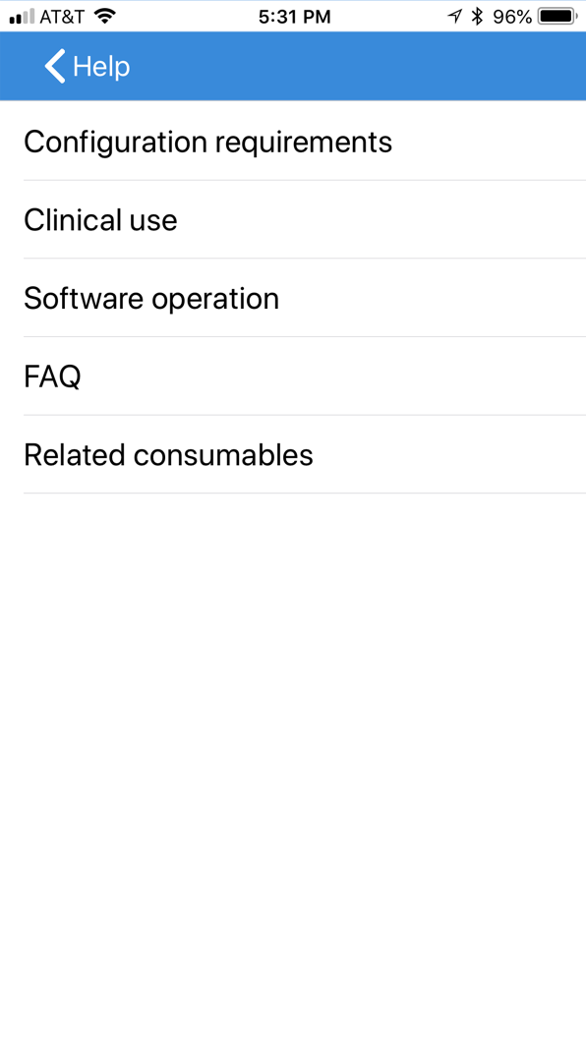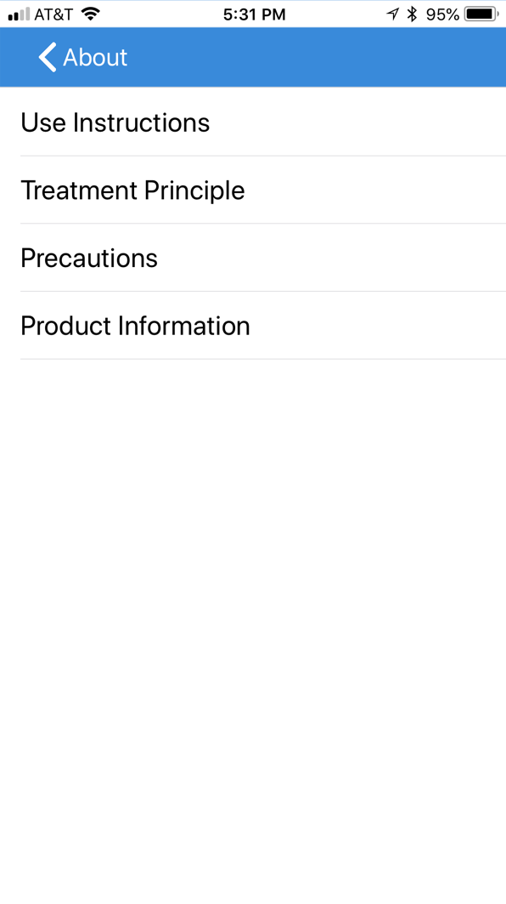

1. The menu from should be as follows: 菜单应该如下：
   1. Rename “Use Instructions” for “Owner’s Manual”. This will be an http link to manual on our website. 将“Use Instructions”重命名为“Owner’s Manual”。这将有我们网站上的手册的http链接。
   2. Remove “Treatment Principle”/ 删除“Treatment Principle”
   3. Leave Precautions. I will provide updated text. 留下 “Precautions”, 我将提供内容。
   4. Leave Product Information but rename to “About Cervella”. 留下 “Product Information”， 改名为to “About Cervella”.
   5. Rename “Configuration Requirements” to “Quick Start Guide”. I will provide contents.   
      即将“Configuration Requirements”重命名为“Quick Start Guide”。我会提供内容。
   6. Remove “Clinical use” 删除“Clinical use”
   7. Remove “Software operation” 删除“Software operation”
   8. Leave FAQ. I will provide contents for the FAQ. 保留FAQ,我将提供FAQ的内容
   9. Rename “Related Consumables” to “Consumables and Accessories Ordering”. This will link to our web-site.

将“相关消耗品”重命名为“消耗品和附件订购”。这将链接到我们的网站。

* 1. Add “Cervella Serial Number: XXXXXXX” on the bottom of the screen if able. If not, it can be skipped. 如果可以的话，在屏幕底部添加“Cervella序列号：XXXXXXX”。如果不容易实现就算了。
  2. Add “Cervella App Version 1.0” on the bottom of the screen. The “1.0” is automatically generated.

在屏幕底部添加“Cervella App Version 1.0”。 “1.0”是自动生成的。

1. IF ABLE RE-ORDER THE MENU ITEMS AS FOLLOWS:
   1. Owner's Manual
   2. Quick Start Guide
   3. Precautions
   4. FAQs
   5. Consumables and Accessories Ordering
   6. About Cervella

如果能够重新排列菜单项如下：

用户手册

快速入门指南

注意事项

常见问题解答

消耗品和配件订购

关于Cervella

APPENDIX A: WORKFLOW

下面的图是根据Somnormal 总结的，请参考。

